|  |  |
| --- | --- |
|  | **LDCW6123 FUNDAMENTALS OF DIGITAL COMPETENCE FOR PROGRAMMERS**  Trimester 2, 2023/2024 |

**Group Project**

## Lecturer : Professor Muhammad Arif Bin Hasan

## Group : DC2 / 2C

*Prepared by:*

|  |  |  |
| --- | --- | --- |
| **Student ID** | **Student Name** | **Phone number** |
| 241UT2408V | WONG WEN FUNG | 011-10730529 |
| 241UT240NM | SHAMAN A/L DEVA KUMAR | 011-72657905 |
| 241UT24014 | ASIM IYAD OMER MUSTAFA | 010-2151275 |

**Declaration by group leader**

I hereby declare that all group members’ names are correctly included in the above section. I hold a copy of this assignment which I can produce if the original is lost or damaged. I certify that no part of this assignment has been copied from any other student’s work or from any other source except where due acknowledgement is made in the assignment.



Group leader’s signature : _____________________________

Group leader’s name : ____WONG WEN FUNG____________

Group leader’s student ID : _____241UT2408V ____________

Date : _____27 JUNE.2024________________

Group leader’s tel. no. : 011-10730529

## Declaration by student

I hereby declare that aforementioned name is correctly included in the above section. I hold a copy of this assignment which I can produce if the original is lost or damaged. I certify that no part of this assignment has been copied from any other student’s work or from any other source except where due acknowledgement is made in the assignment.

For the purpose of completing this assignment, I have performed the following tasks (please list):

- Wix Website design of our company

- Project arrangement

- Conclusion



Student signature :

Student name : WONG WEN FUNG

Student ID : 241UT2408V

Date : 27 JUNE 2024

Group member’s tel. no. : 011-10730529

## Declaration by student

I hereby declare that aforementioned name is correctly included in the above section. I hold a copy of this assignment which I can produce if the original is lost or damaged. I certify that no part of this assignment has been copied from any other student’s work or from any other source except where due acknowledgement is made in the assignment.

For the purpose of completing this assignment, I have performed the following tasks (please list):

- Mobile App

- manual user

- video presentation



Student signature :

Student name : ASIM IYAD OMER

Student ID :241UT24014

Date : 27/6/2024

Group member’s email : asim.iyad.omer@student.mmu.edu.my

Group member’s tel. no. : _0102151275______________________

## Declaration by student

I hereby declare that aforementioned name is correctly included in the above section. I hold a copy of this assignment which I can produce if the original is lost or damaged. I certify that no part of this assignment has been copied from any other student’s work or from any other source except where due acknowledgement is made in the assignment.

For the purpose of completing this assignment, I have performed the following tasks (please list):

-

-

-

Student signature :

Student name :

Student ID :

Date :

Group member’s email :

Group member’s tel. no. : ________________________________

**Website & Mobile apps prototype evaluation**

|  |  |  |  |  |  |
| --- | --- | --- | --- | --- | --- |
| **Criteria** | Excellent (5) | Good (4) | Satisfactory (3) | Needs Improvement (2) | Inadequate (1) |
| 1. **User Interface & Design (15 marks)** | | | | | |
| * Visual Appeal |  |  |  |  |  |
| * Navigation and Layout |  |  |  |  |  |
| * Consistency in Design Elements |  |  |  |  |  |
| 1. **Functionality & Interactivity (15 marks)** | | | | | |
| * Responsive Design |  |  |  |  |  |
| * Feature Integration |  |  |  |  |  |
| * Cross-browser Compatibility |  |  |  |  |  |
| 1. **Content Quality (15 marks)** | | | | | |
| * Relevance and Accuracy of Information |  |  |  |  |  |
| * Readability and Clarity |  |  |  |  |  |
| * Multimedia Integration |  |  |  |  |  |
| 1. **Accessibility & Inclusivity (15 marks)** | | | | | |
| * Compliance with Accessibility Standards |  |  |  |  |  |
| * Inclusive Design |  |  |  |  |  |
| * Overall Website & prototype performance |  |  |  |  |  |
| **Total (60 marks)** | | | | | |

**Designing and Developing Website and Mobile Apps Prototypes in Collaboration with Git & GitHub**

WONG WEN FUNG, SHAMAN A/L DEVA KUMAR, and ASIM IYAD OMER MUSTAFA

Faculty of Information Science & Technology (FIST), Multimedia University Melaka

LCBW6192: Fundamental of Digital Competence of Programmers

Professor Muhammad Arif Bin Hasan

27 JUNE 2024

**Content**

1. Website URL Link …………………………………………………9
2. Mobile Apps URL Link ……………………………………………11
3. Mobile Apps User Manual …………………………………………

**E-commerce Website**

**FINIX**

**Second-Hand Anime figure and Fan-Art selling platform**

[Home | Finixanime (wenfung118.wixsite.com)](https://wenfung118.wixsite.com/finixanime) 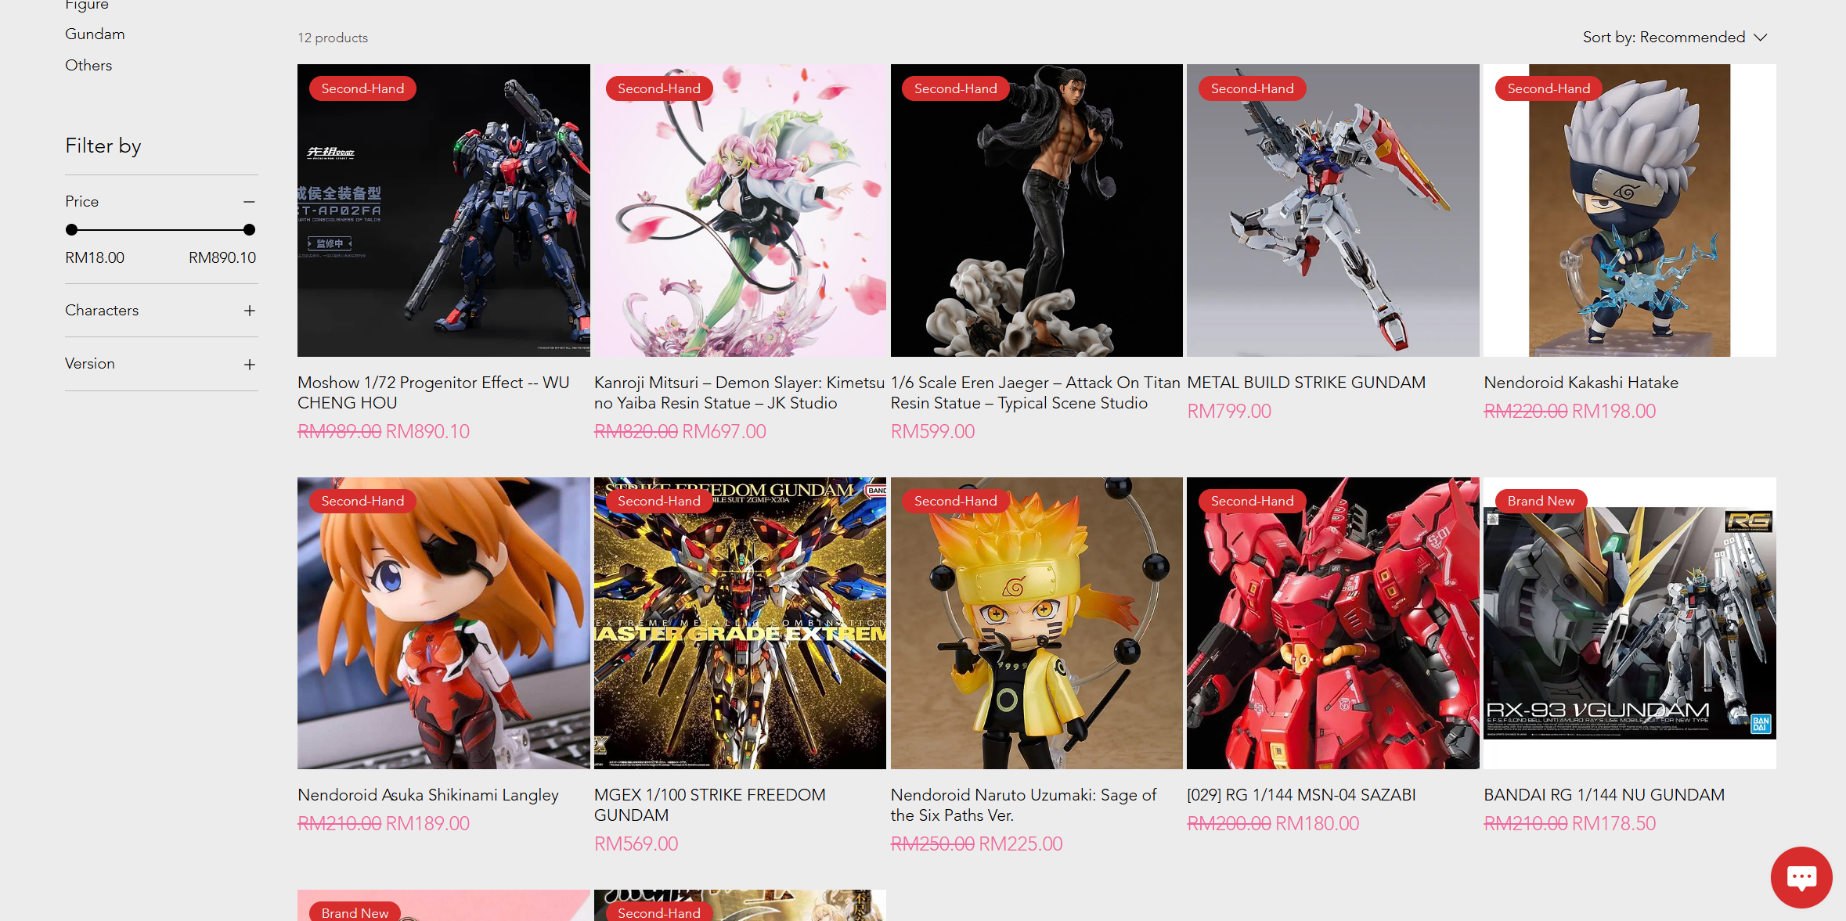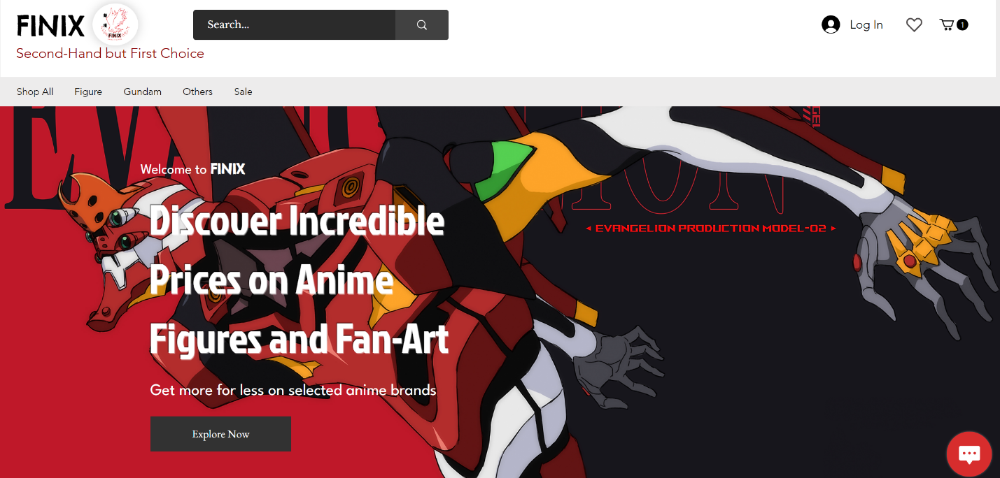

Figure 1.0: Wix e-commerce website

**Site Map**

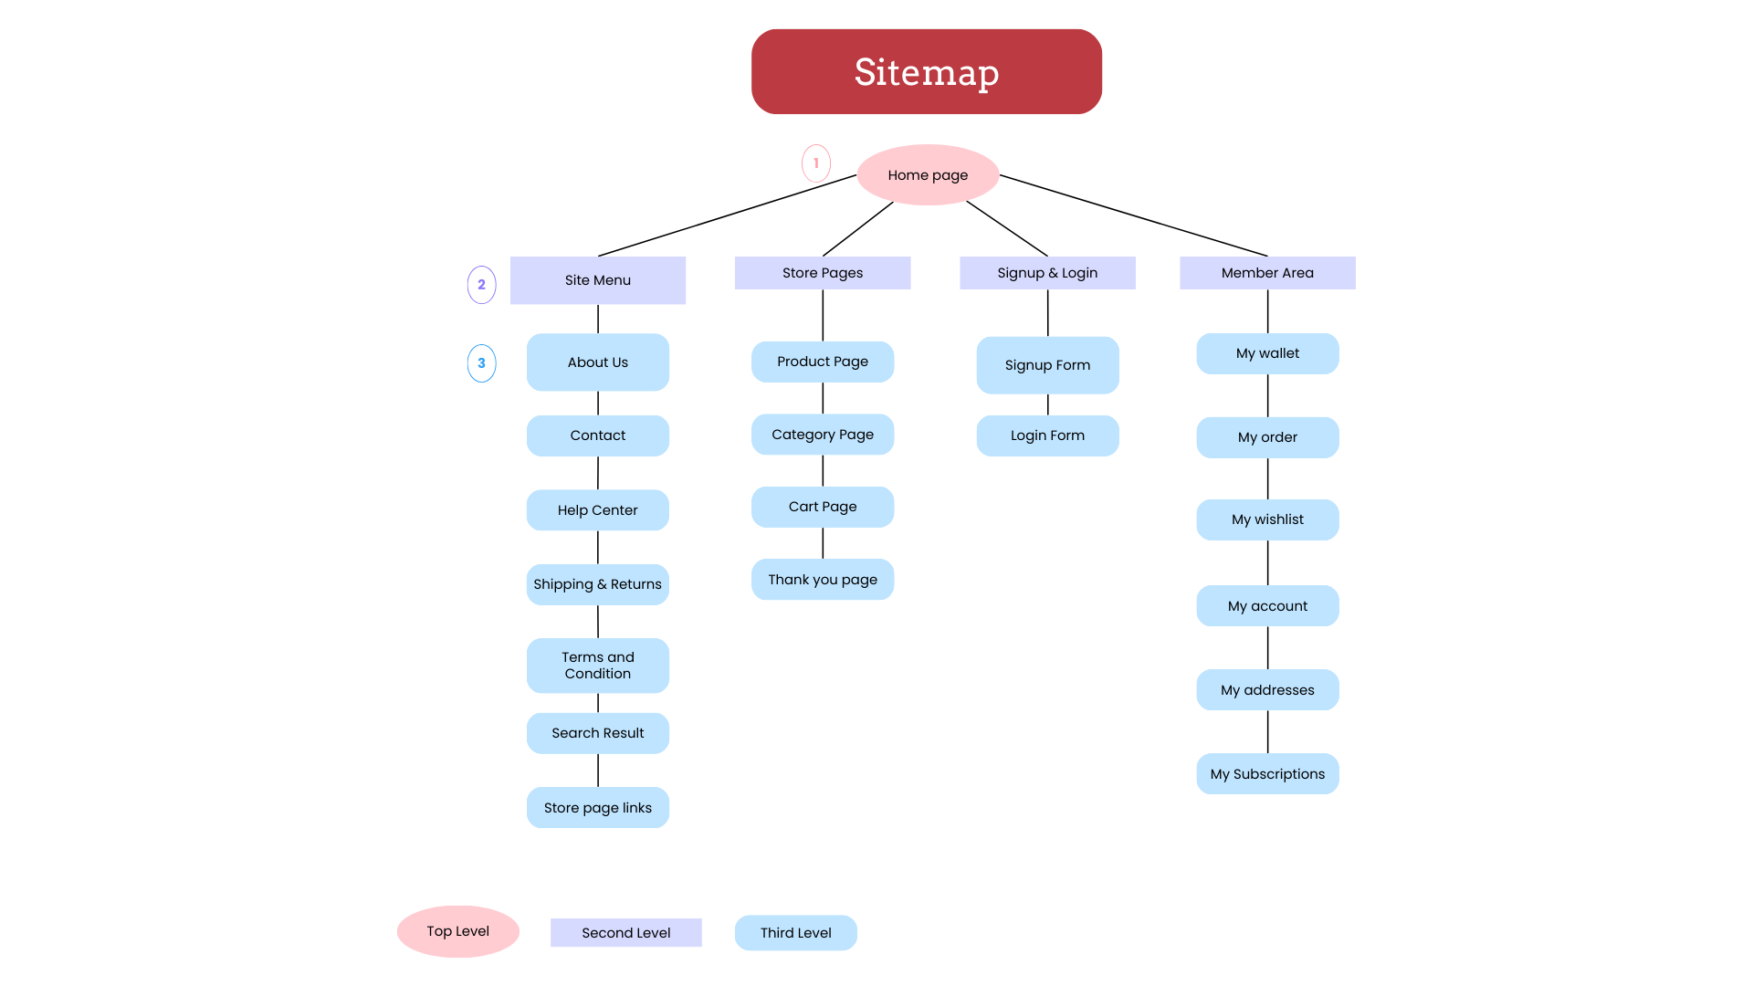

Figure 1.1: Website sitemap

**Mobile App**

**commerce Mobile App**

**FINIX**

**Second-Hand Anime figure and Fan-Art selling platform**

[**https://www.figma.com/proto/exgHgZmiA62Ha23KFas8FZ/Untitled?node-id=0-1&t=hl8cdc70ETPCOU6v-1**](https://www.figma.com/proto/exgHgZmiA62Ha23KFas8FZ/Untitled?node-id=0-1&t=hl8cdc70ETPCOU6v-1)

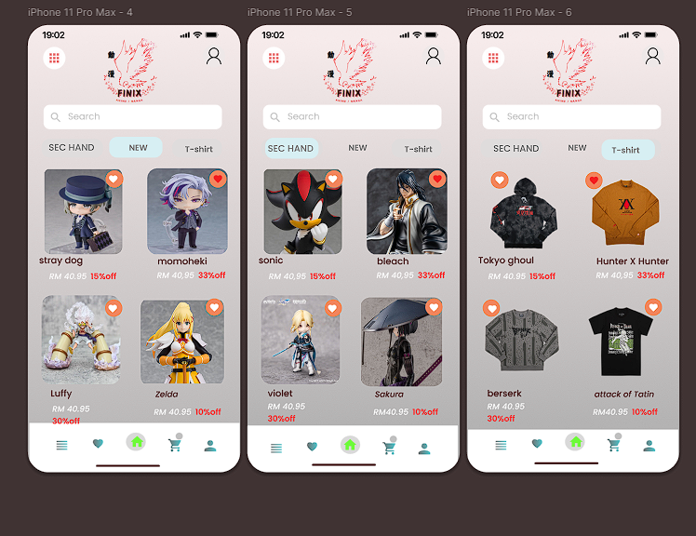**To continue**

**Mobile Apps User Manual**

**Introduction**

Welcome to the Finix Mobile App User Manual. This guide is designed to help you navigate and make the most of our app, ensuring a seamless experience as you explore our collection of anime figures.

***Outline Target Audience for the Manual***

This manual is aimed at all Finix customers who are passionate Anime fans, collectors and enthusiasts who are interested in buying, new or used Anime figures. Whether you are a veteran collector or a newcomer to the anime, you will be able to familiarize yourself and start using all the features of our application.

**Provide Brief Overview of Purpose and Functionality**

The goal of this manual is to explain the salient features of the Finix mobile application by describing how it works. Users will be able to find out how to sign up, how to navigate through the anime figure collections, how to pick products and complete a purchase, as well as how to maneuver the cart. So, our app developed to be user friendly and entertaining so you can easily enjoy your favorite anime figures shopping.

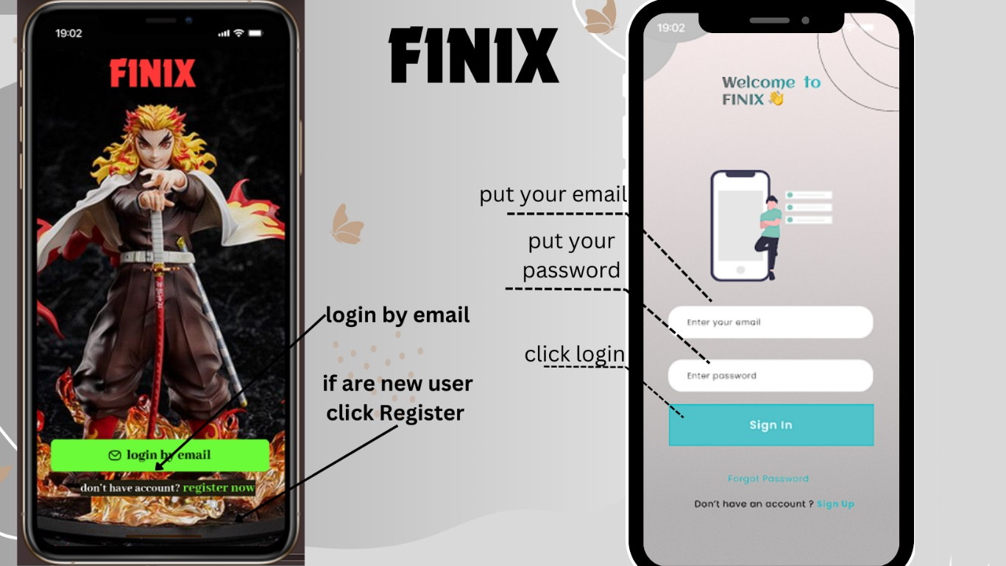

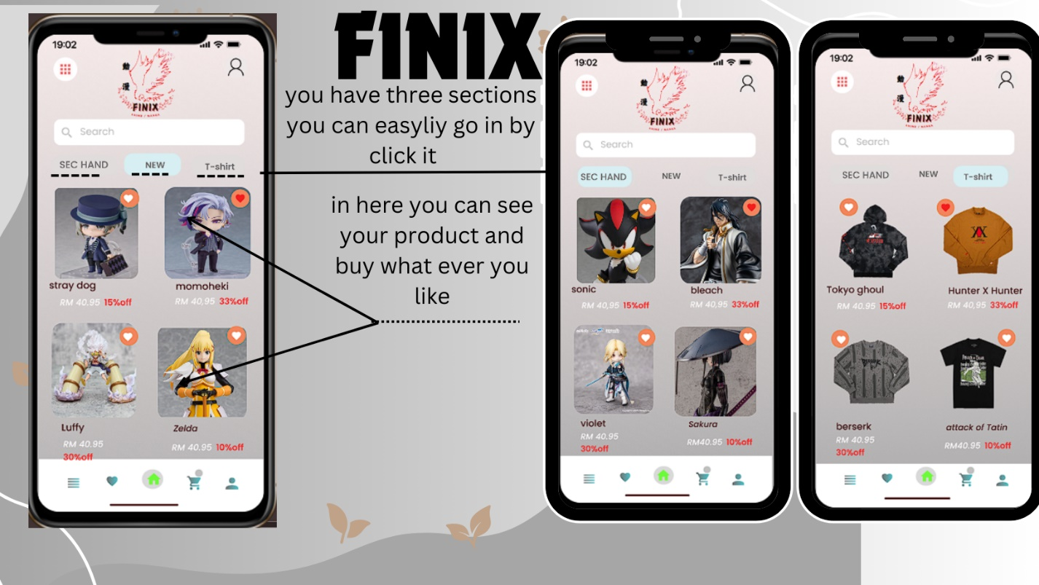

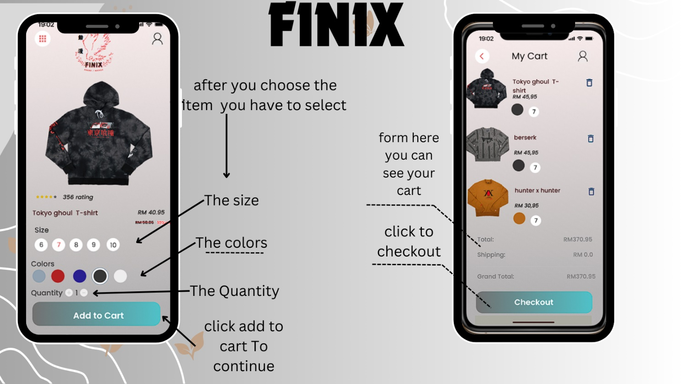

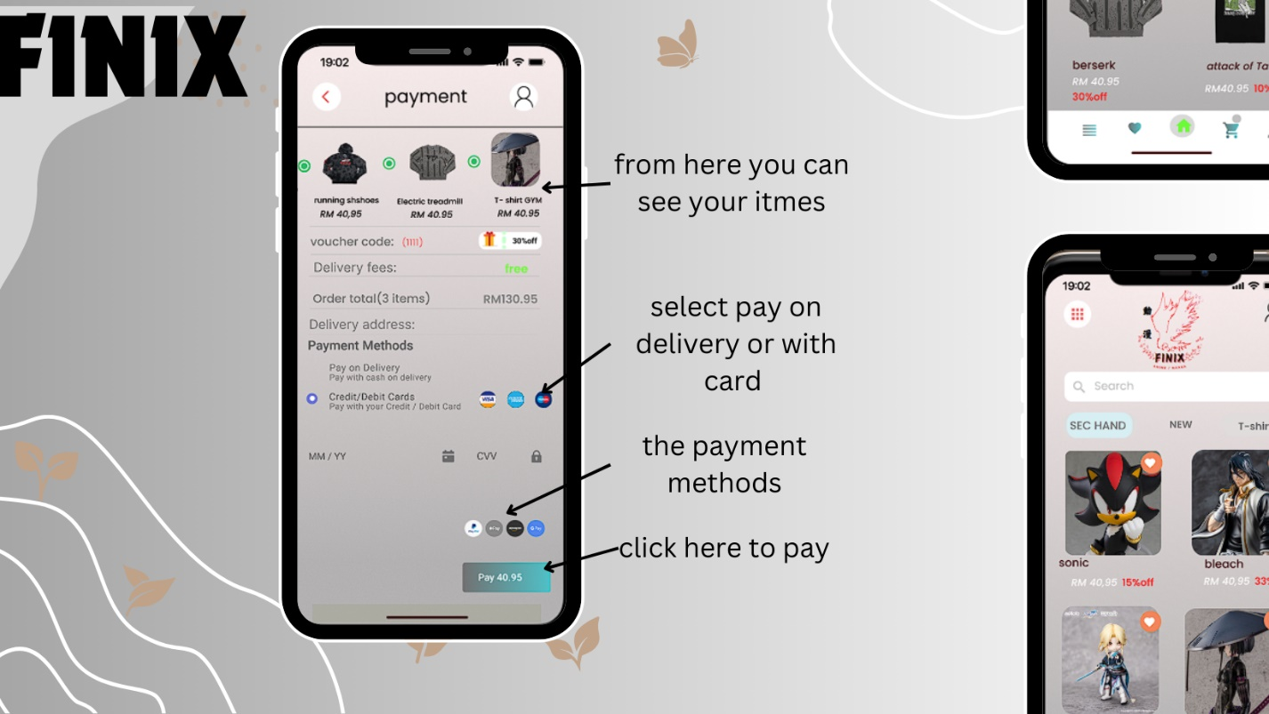

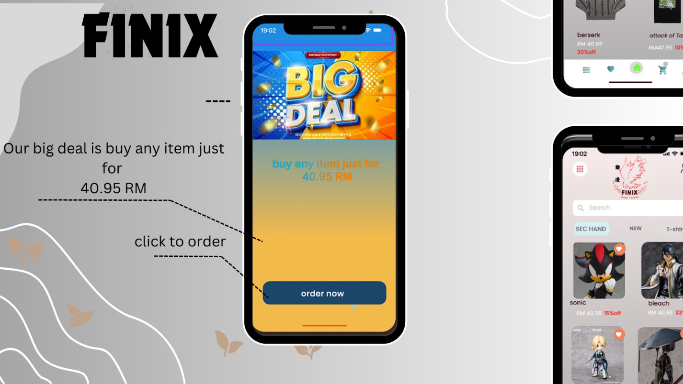

**The User Interface and the Design of the Finix Mobile Application**

Since the Finix mobile app has been developed as a shopping application, it has a proper interface with nice-looking graphics. Below is an explanation of the key visual elements:Below is an explanation of the key visual elements:

***Color Scheme***

The color scheme of the app looks rather stylish and up-to-date; it uses plenty of non-bright but contrasty colors with black and white as the primary ones. The primary colors used are:The primary colors used are:

Grey: The background appears as a soft grey that creates a perfect backdrop on which the anime figures easily find a home as they are very prominent.

White: White is used in the text areas and sections so that the text can be read easily with no interferences by colors from the vicinity.

Teal and Coral: These accent colours are used for buttons and highlights, you get that amazing buzz and the colour really makes you stand out important interactive regions.

**Logo**

At the top of the Finix application, there is a logo which is easily noticeable by any user. It features:

Stylized Text: This is followed by the brand name ‘FINIX’ written in capital letters, with an exclusively chosen font that has a futuristic feel, which is assembles the vibe and spirit of anime fans.

Anime Character: A character from an anime is incorporated into the logo, hence the emphasis on anime figures and appealing to the intended audience of anime lovers.

***Visual Layout***

The app's visual layout is designed to be intuitive and user-friendly:The app's visual layout is designed to be intuitive and user-friendly:

Homepage: Who contains a top banner of a new or featured anime figure, which draws the user’s attention at once.

Navigation Bar: The displayed option bar is ordinary and easily understandable andincludes buttons for categories, cart, and account.

Product Display: An anime figure is illustrated with an excellent photo, description, and concise convenient prices; therefore, clients receive all the necessary information to make the right decision.

Altogether, these visual elements are helpful and effective in delivering a positive and convenient shopping experience to the consumers of Finix to enable them to find and buy their most attractive anime figures.

**Video Presentation**

**Here**

**GitHub Log activities**

**Conclusion**

This project is a new challenge of us and our team, because none of us has use GitHub and its function before. But thankfully we manage to overcome the challenge together. Wix.com is surely a handy tool for all of us, the easy and simple UI makes design a website so easily and efficiently. For me, I love the part of we can actually choose a template to start with, so that we wouldn’t have to start from zero. This function surely gives a lot convenient, thus it not only shortens the time that we need to implement the section of our website, it also kind of providing ideas to us that how we going to set our function and also the design element. The point that need to mention is, as we didn’t subscribe the Wix.com; it result us we can not activate the payment method, this is the point we all feeling bad.

Then, Figma is another handy tool for student to design their application on mobile phone. Simple and easy use function really helps a lot, because we do not need to study all of the basic coding language in order to start our design.

After this, GitHub log sure takes us some time to figure it out what we going to do. But after some basic introduction and the help of lecturer, we mange to finish our work at the time.